SUSAN SH

CHANGES TO APPT SYSTEM

DUE TO REDUCTION IN OUR GP TEAM

There will be a reduced number of Routine prebookable Appts

Most appointments will now be 24hour or Book on the Day.

All URGENT issues will be passed to Duty Team to Action.

**Our Phone Lines will now only accept Emergency Calls between 1200 – 1300 and 1700 and 1800 **

Please bear with us during this busy period.

PARTNER LEAVING - DR DAKSHA BHADRASHETTY

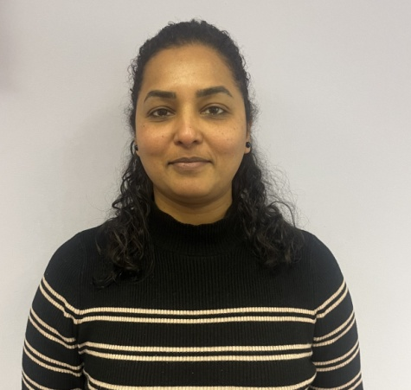
We are sad to announce that Dr Daksha Bhadrashetty will be leaving Garthdee Medical Group as of 30th June 20024.

We would like to wish her the very best for the future.

